**Lab # 03: Improved Web Design using CSS/Bootstrap**



**Fall 2024**

Submitted by: **Mohsin Sajjad**

Registration No: **22pwsce2149**

Class Section: **A**

“On my honor, as student of University of Engineering and Technology, I have neither given nor received unauthorized assistance on this academic work.”



Student Signature: ______________

Submitted to:

**Engr. Summeya Salahudin**

Month Day, Year (03,13, 2025)

Department of Computer Systems Engineering

University of Engineering and Technology, Peshawar

**OBJECTIVES OF THE LAB**

This lab aims at the understanding of:

1. The concept of Dynamic HTML
2. Cascaded Style Sheets (CSS)
3. Various attributes of CSS such as font, color, background, text, border, margin, and list
4. User-Defined Selectors including Class and ID
5. Span and Div Tags
6. External Style Sheets and their benefits.

**Task 3.1** LAB PERFORMANCE: Read the provided lab document carefully, prepare your lab report during the lab and submit it to your lab instructor during lab timing. (10 Marks) 1. **Practical 1:** Understand and go through all the 8 examples provided in this lab. Try each one in your favorite IDE. Check the output in browser. In your lab report, write comment about each example you have covered in your own words with that example output. (6 Marks)

**Example 01:**

**Code:**

<!DOCTYPE html>

<html lang="en">

<head>

<meta charset="UTF-8">

<meta name="viewport" content="width=device-width, initial-scale=1.0">

<title>Working with Style Sheets</title>

<style>

h1 {

font-family: Arial, Helvetica, sans-serif;

font-size: 26pt;

color: red;

}

p {

font-size: 12pt;

font-weight: bold;

font-style: italic;

color: #23238e;

border: thick groove black;

padding: 10px;

}

</style>

</head>

<body>

<h1>Silicon Chip Technologies</h1>

<p>A private limited company, which was founded in December 1989. The vision of this

company is to provide any corporate client a single entity which addresses all their

Software Development, Technical and User Documentation, Training and Manpower

Recruitment needs.</p>

</body>

</html>

**Output:**



**Comment:**

• **Defines a simple webpage** with a title and basic content.  
• **Uses CSS inside the <style> tag** to apply font styles.  
• **The <h1> heading** is displayed using **Arial or Helvetica** font family.  
• **Paragraphs (<p>)** are styled with **12pt font size, italic text, and normal weight** for readability.  
• **Displays company information** in a structured way with a heading and descriptive text.

**Example 02:**

**Code:**

<html>

<head>

    <title>Working with Style Sheets using Color and Background Attributes</title>

    <style type="text/css">

        h1 {font-family:arial, helvetical;

            font-size:26pt;

            background-image:url(images/logo2.jpg)}

        h2 {font-family:arial, helvetical;

            font-size:26pt;

            background-image:url(images/logo2.jpg);

            background-repeat:no-repeat}

        p {font-size:12pt;

            font-style:italic;

            font-weight:bold;

            color:#23238e;

            background-color:red;

            background-position:bottom-left}

    </style>

</head>

<body>

    <b><u>With background repeat</u></b>

    <h1>Silicon Chip Technologies</h1>

    <p>A private limited company, which was founded in December 1989.

    The vision of this company is to provide any corporate client a single entity

    which addresses all their Software Development, Technical and User

    Documentation, Training and Manpower Recruitment needs.</p><br>

    <b><u>With background no-repeat</u></b>

    <h2>Silicon Chip Technologies</h2>

</body>

</html>

**Output:**



**Comment:**

• Defines a webpage with a title and content using HTML and CSS.  
• Uses CSS to style <h1>, <h2>, and <p> elements with fonts, colors, and backgrounds.  
• The <h1> and <h2> headings use Arial/Helvetica font (26pt) and a background image (logo2.jpg).  
• The <h1> repeats the background image, while the <h2> does not repeat it (background-repeat: no-repeat).  
• Paragraphs (<p>) are 12pt, bold, italic, and colored (#23238e) with a red background positioned at the bottom-left.  
• Demonstrates background image behavior with repeat vs. no-repeat styles.

**Example 03:**

**Code:**

<html>

<head>

    <title>Working with Style Sheets using Text Attributes</title>

    <style type="text/css">

        h1 {

            font-family: arial, helvetica;

            font-size: 26pt;

            text-decoration: none; /* 'blink' is deprecated */

            color: red;

        }

        p {

            font-size: 12pt;

            font-style: normal;

            font-weight: bold;

            color: #23238e;

        }

        h6 {

            font-size: 12pt;

            font-style: italic;

            font-weight: bold;

            color: #23238e;

            text-align: justify;

            text-indent: .5in;

        }

    </style>

</head>

<body>

    <h1>Silicon Chip Technologies</h1>

    <b><u>Without text align, first line indent</u></b>

    <p>A private limited company, which was founded in December 1989.

        The vision of this company is to provide any corporate client a single entity

        which addresses all their Software Development, Technical and User

        Documentation, Training, and Manpower Recruitment needs.

    </p>

    <b><u>With text align (justify), first line indent</u></b>

    <h6>A private limited company, which was founded in December 1989.

        The vision of this company is to provide any corporate client a single

        entity which addresses all their Software Development, Technical and

        User Documentation, Training, and Manpower Recruitment

        needs.

    </h6>

</body>

</html>

**Output:  
**

**Comment:**

• Creates a webpage with a title and content styled using CSS.  
• The <h1> heading uses Arial/Helvetica (26pt), red color, and no text decoration.  
• The <p> tag has 12pt font size, bold text, and blue color (#23238e).  
• The <h6> tag has italic, bold text (12pt, blue), justified alignment, and a first-line indent of 0.5 inches.  
• Demonstrates text alignment and indentation differences between <p> and <h6>.  
• Shows how text can be justified and styled for better readability.

**Example 04:**

**Code:**

<html>

<head>

    <title>Use of Margin Attributes</title>

    <style type="text/css">

        body { margin-top: 10%; }

        h1 {

            font-family: arial, helvetica;

            font-size: 26pt;

            color: red;

        }

        p {

            font-size: 12pt;

            font-style: italic;

            font-weight: bold;

            color: #23238e;

            text-align: justify;

            margin-left: 15%;

            margin-right: 15%;

        }

    </style>

</head>

<body>

    <h1>Silicon Chip Technologies</h1>

    <b><u>Without text align, first line indent</u></b>

    <p>A private limited company, which was founded in December 1989. The

       vision of this company is to provide any corporate client a single entity

       which addresses all their Software Development, Technical and User

       Documentation, Training and Manpower Recruitment needs.

    </p>

</body>

</html>

**Output:**

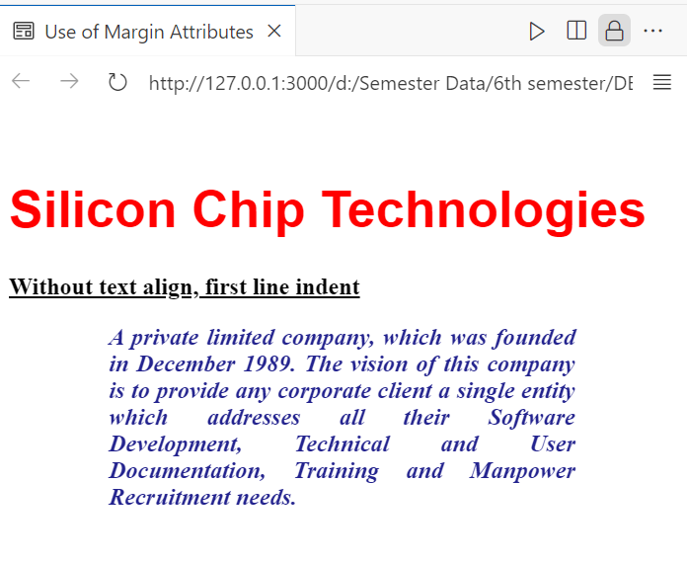

**Output:**

• **Defines a webpage** with a title and styled content using CSS.  
• **The <body> has a top margin of 10%**, creating spacing from the top of the page.  
• **The <h1> heading** is styled with **Arial/Helvetica (26pt), red color**.  
• **The <p> tag** has **12pt italic bold text, blue color (#23238e), justified alignment**.  
• **Left and right margins of 15%** are applied to the paragraph for better readability.  
• **Demonstrates how margins and text alignment** can improve content presentation.

**Example 05:**

**Code:**

<html>

<head>

    <title>Use of Margin Attributes</title>

    <style type="text/css">

        p {font-size:12pt;

            font-weight:bold;

            text-align:justify;

            margin-left:10%;

            margin-right:10%;}

        .question {color: brown; font-style: italic;}

        .answer {color:#23238e;}

    </style>

</head>

<body>

    <p class="question">How to create a style sheet to alter an HTML element?</p>

    <p class="answer">The Style assignment process can be accomplished with

    the &lt;STYLE&gt;...&lt;/STYLE&gt; tags. The syntax for making the

    assignment is simple. Between &lt;STYLE&gt; and &lt;/STYLE&gt;, HTML tags

    to which styles are to be assigned are to be listed, each tag with a pair of

    curly brackets in which specific style attributes are to be specified. This

    &lt;STYLE&gt; tag should be within &lt;HEAD&gt;...&lt;/HEAD&gt;

    element.</p>

    <br>

    <p class="question">What are the attributes that can be specified?</p>

    <p class="answer">The attributes that can be specified are: Font attributes,

    Color and Background attributes, Text attributes, Border attributes, Margin

    attributes, and List attributes.</p>

</body>

</html>

**Output:**

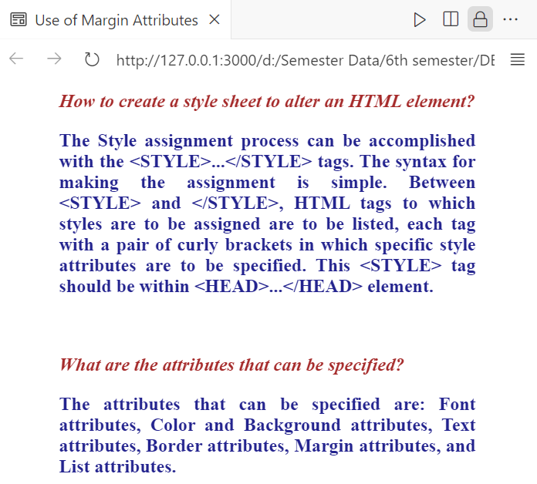

**Comment:**

• **Creates a webpage** with styled questions and answers using CSS.  
• **The <p> tag** has **12pt bold text, justified alignment, and 10% left/right margins**.  
• **Defines two classes:**

* **.question** → Brown-colored, italic text for questions.
* **.answer** → Blue-colored text (#23238e) for answers.  
  • **Uses <br>** to add spacing between different Q&A sections.  
  • **Explains how to apply styles using the <style> tag** and lists different CSS attributes.

**Example 06:  
Code:**

<html>

<head>

    <title>Working with Span</title>

    <style type="text/css">

        p {

            font-size: 12pt;

            font-weight: bold;

            text-align: justify;

        }

        .question {

            color: brown;

            font-style: italic;

        }

        .answer {

            color: #23238e;

        }

        .big {

            font-size: 14pt;

            text-decoration: underline;

            text-transform: uppercase;

            color: red;

        }

    </style>

</head>

<body>

    <p class="question">How to create <span class="big">style sheet</span> to alter an HTML element?</p>

    <p class="answer">The Style assignment process can be accomplished with the &lt;STYLE&gt;...&lt;/STYLE&gt; tags. The syntax for making the assignment is simple. Between &lt;STYLE&gt; and &lt;/STYLE&gt;, HTML tags to which styles are to be assigned are to be listed, each tag with a pair of curly brackets in which specific style attributes are to be specified. This &lt;STYLE&gt; tag should be within &lt;HEAD&gt;...&lt;/HEAD&gt; element.</p>

    <br>

    <p class="question">What are the <span class="big">attributes</span> that can be specified?</p>

    <p class="answer">The attributes that can be specified are: Font attributes, Color and Background attributes, Text attributes, Border attributes, Margin attributes, and List attributes.</p>

</body>

</html>

**Output:**

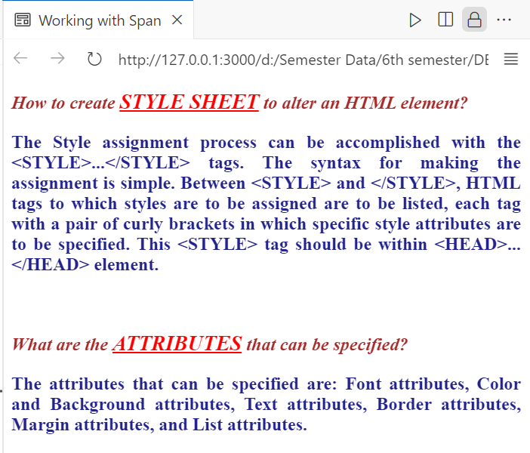

**Comment:**

• **Creates a webpage** with styled text using <span> for inline styling.  
• **The <p> tag** has **12pt bold, justified text**.  
• **Defines three CSS classes:**

* **.question** → Brown, italic text for questions.
* **.answer** → Blue-colored text (#23238e) for answers.
* **.big** → **Larger (14pt), underlined, uppercase, red text** for emphasis.  
  • **Uses <span class="big">...</span>** inside paragraphs to highlight key words.  
  • **Explains how to use the <style> tag** and lists CSS attributes.

**Example 07:**

**Code:**

<html>

<head>

    <title>Product Brochure</title>

    <style type="text/css">

        div { font-weight: bold; }

        div#sidebar {

            font-family: Arial;

            float: inherit;

            color: red;

            width: 200px;

            text-align: justify;

        }

        div.articlebox {

            width: 500px;

            border: 1px solid black;

        }

    </style>

</head>

<body>

    <div id="sidebar">

        <p>

            Congratulations on the purchase of your sword! Using a sword is fun

            and easy. Just be sure to follow these important safety tips.

        </p>

    </div>

    <div>

        <p><em>Never</em> hold your sword by the pointy end.</p>

        <p><em>Always</em> be sure to stick the pointy end

            into the other guy before he does the same to you.

        </p>

    </div>

    <div class="articlebox">

        <p>

            And remember, if you or your surviving kinsfolk are not fully satisfied,

            we have a money-back guarantee!

        </p>

    </div>

</body>

</html>

**Output:**

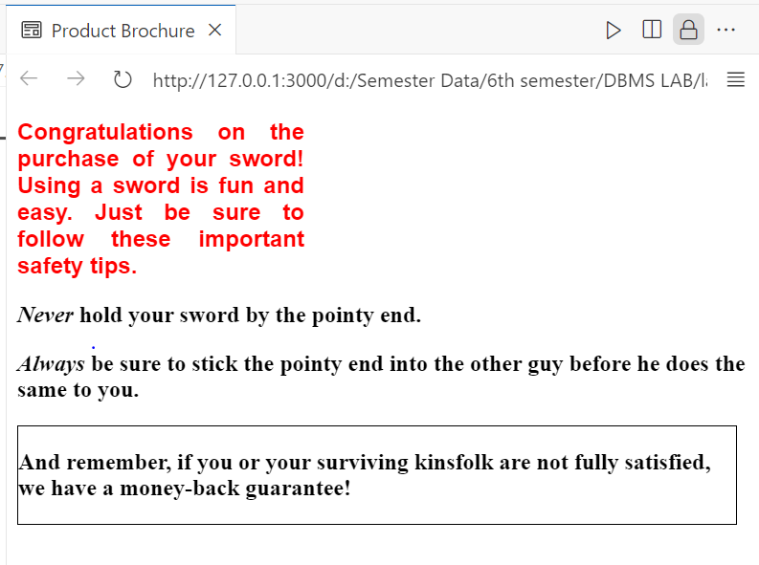

**Comment:**

• **Creates a product brochure webpage** with styled content inside <div> elements.  
• **Defines three CSS styles:**

* **All <div> elements** → Bold text.
* **#sidebar (red text, Arial font, 200px width, justified text)** → Used for the sidebar.
* **.articlebox (500px width, black border)** → Styled for product guarantee details.  
  • **Float: inherit in #sidebar** is unnecessary because it does not inherit a float by default.  
  • **Content layout:**
* Sidebar introduces the product (a sword) and safety tips.
* General <div> contains sword handling instructions.
* .articlebox provides a **money-back guarantee** statement.

**Example 08:**

**Code:**

**mystyle.css**

p {font-size:12pt; font-weight: bold; text-align: justify;}

.question {color: brown; font-style: italic;}

.answer {color:#23238e}

.big {font-size:14pt; text-decoration: underline; text-transform: uppercase;

color: red;}

**Ex08.html**

<!DOCTYPE html>

<html>

<head>

    <title>Working with External Style Sheet</title>

    <link rel="stylesheet" href="mystyle.css">

</head>

<body>

    <p class="question">How to create <span class="big">style sheet</span> to alter an HTML element?</p>

    <p class="answer">The Style assignment process can be accomplished with the &lt;STYLE&gt;...&lt;/STYLE&gt; tags.

    The syntax for making the assignment is simple. Between &lt;STYLE&gt; and &lt;/STYLE&gt;, HTML tags to which styles

    are to be assigned are to be listed, each tag with a pair of curly brackets in which specific style attributes

    are to be specified. This &lt;STYLE&gt; tag should be within &lt;HEAD&gt;...&lt;/HEAD&gt; element.</p>

    <br>

    <p class="question">What are the <span class="big">attributes</span> that can be specified?</p>

    <p class="answer">The attributes that can be specified are: Font attributes, Color and Background attributes,

    Text attributes, Border attributes, Margin attributes, and List attributes.</p>

</body>

</html>

**Output:**

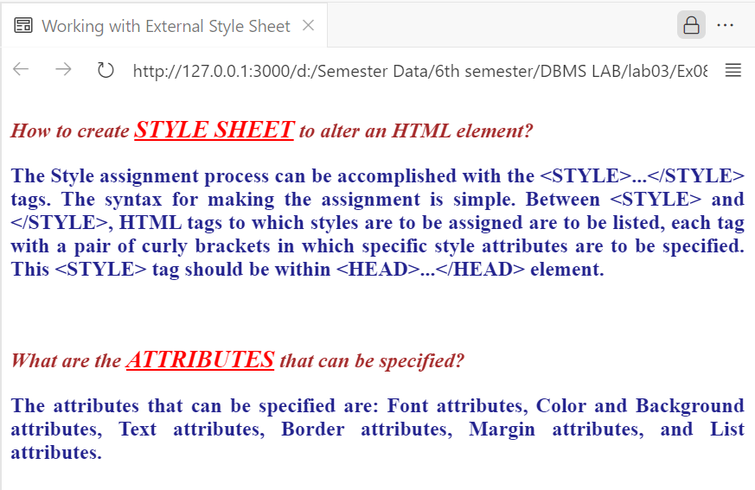

**Comment:**• **Defines a structured HTML page** with a title and external CSS for styling.  
• **Links an external stylesheet (mystyle.css)** using the <link> tag in the <head>.  
• **Styles <p> elements globally:**

* Sets **font size to 12pt** for readability.
* Makes text **bold** and **justified** for a clean look.  
  • **Customizes elements with specific classes:**
* **.question class:** Colors text **brown** and applies **italic** styling.
* **.answer class:** Colors text **#23238e (dark blue)** for contrast.
* **.big class:**
  + Sets **font size to 14pt** for emphasis.
  + Makes text **uppercase, red, and underlined** for visibility.  
    • **Enhances readability and structure** by differentiating questions and answers visually.

**Practical 2:** Write the HTML code with CSS that generates the web page shown in Figure 3.8 with following specification: a) Heading 1 has font value of Arial and Helvetica, size 26 pts, and red color. b) Each paragraph is 12 pts, bold, and italic. Take paragraph color value: #23238e c) Use groove border style and thick border width. For reference, go to Table 4.4 for further details about the border attributes. Provide the HTML and CSS codes in your lab report. (4 Marks)

**Code:**

<!DOCTYPE html>

<html lang="en">

<head>

    <meta charset="UTF-8">

    <meta name="viewport" content="width=device-width, initial-scale=1.0">

    <title>Working with Style Sheets</title>

    <style>

        h1 {

            font-family: Arial, Helvetica, sans-serif;

            font-size: 26pt;

            color: red;

        }

        p {

            font-size: 12pt;

            font-weight: bold;

            font-style: italic;

            color: #23238e;

            border: thick groove black;

            padding: 10px;

        }

    </style>

</head>

<body>

    <h1>Silicon Chip Technologies</h1>

    <p>A private limited company, which was founded in December 1989. The vision of this

    company is to provide any corporate client a single entity which addresses all their

    Software Development, Technical and User Documentation, Training and Manpower

    Recruitment needs.</p>

</body>

</html>

**Output:**



**Comment:**

• Defines a structured HTML page with a title and styled content.  
• Uses the <style> tag in the <head> to apply CSS styles directly within the document.  
• Customizes <h1> styles:

* Uses Arial, Helvetica, sans-serif as the font family.
* Sets font size to 26pt for emphasis.
* Colors the text red for visibility.  
  • Styles <p> elements:
* Sets font size to 12pt for readability.
* Applies bold and italic formatting for emphasis.
* Colors the text #23238e (dark blue) for contrast.
* Adds a thick groove black border around paragraphs.
* Uses 10px padding for spacing inside the border.

**--------------------------Task 3.2--------------------------** **Homework 1:** Write the HTML code with CSS that generates the web page shown in Figure 3.9 with following specification: 1) Heading 1 has font value of Garamond, size 26 pts, and red color. 2) Set top margin to 5%. 3) Create unordered list with values: HTML, JavaScript, CGI, Java, Oracle Developer 2000, and Oracle DBA. Use square list style type.

**Code:**

<!DOCTYPE html>

<html lang="en">

<head>

    <meta charset="UTF-8">

    <meta name="viewport" content="width=device-width, initial-scale=1.0">

    <title>Silicon Chip Technologies</title>

    <style>

        body {

            margin-top: 5%;

        }

        h1 {

            font-family: Garamond, serif;

            font-size: 26pt;

            color: red;

        }

        ul {

            list-style-type: square;

        }

    </style>

</head>

<body>

    <h1>Silicon Chip Technologies</h1>

    <p>SCT provides Corporate Training for the following products:</p>

    <ul>

        <li>HTML</li>

        <li>JavaScript</li>

        <li>CGI</li>

        <li>Java</li>

        <li>Oracle Developer 2000</li>

        <li>Oracle DBA</li>

    </ul>

</body>

</html>

**Output:**



**Description:**

* **Title:** *Silicon Chip Technologies*
* **Purpose:** Displays corporate training information.
* **Styling Features:**
  + **Body:** Top margin set to 5%.
  + **Heading (h1)**: Uses *Garamond* font, 26pt size, and red color.
  + **List (ul)**: Uses square bullet points.
* **Content:**
  + A heading for the company name.
  + A paragraph describing training services.
  + A bulleted list of training topics.

**--------------------------Task 3.3-------------------------- Homework 2:** Write the HTML code along with CSS file that generates the output web page shown in Figure 3.9.

**CODE:**

**Html:**

<!DOCTYPE html>

<html lang="en">

<head>

    <meta charset="UTF-8">

    <meta name="viewport" content="width=device-width, initial-scale=1.0">

    <title>Silicon Chip Technologies</title>

    <link rel="stylesheet" href="styles.css">

</head>

<body>

    <h1>Silicon Chip Technologies</h1>

    <p>SCT provides Corporate Training for the following products:</p>

    <ul>

        <li>HTML</li>

        <li>JavaScript</li>

        <li>CGI</li>

        <li>Java</li>

        <li>Oracle Developer 2000</li>

        <li>Oracle DBA</li>

    </ul>

</body>

</html>

**CSS:**

body {

    margin-top: 5%;

}

h1 {

    font-family: Garamond, serif;

    font-size: 26pt;

    color: red;

}

ul {

    list-style-type: square;

}

**Output:**



**Description:**

* **Title:** *Silicon Chip Technologies*
* **Purpose:** Displays information about corporate training services.
* **Technologies Used:** HTML and external CSS (styles.css).
* **Content:**
  + A **heading** (<h1>) for the company name.
  + A **paragraph** (<p>) describing the training services.
  + A **bulleted list** (<ul>) of training topics, including HTML, JavaScript, Java, and Oracle.

**-------------------------Task 3.4-------------------------- Homework 3:** Rewrite Example 5 using ID Selector instead of class Selector and show its output.

**CODE:**

<!DOCTYPE html>

<html>

<head>

    <title>Use of Margin Attributes</title>

    <style type="text/css">

        p {

            font-size: 12pt;

            font-weight: bold;

            text-align: justify;

            margin-left: 10%;

            margin-right: 10%;

        }

        #question {

            color: brown;

            font-style: italic;

        }

        #answer {

            color: #23238e;

        }

    </style>

</head>

<body>

    <p id="question">How to create a style sheet to alter an HTML element?</p>

    <p id="answer">The Style assignment process can be accomplished with

    the &lt;STYLE&gt;...&lt;/STYLE&gt; tags. The syntax for making the

    assignment is simple. Between &lt;STYLE&gt; and &lt;/STYLE&gt;, HTML tags

    to which styles are to be assigned are to be listed, each tag with a pair of

    curly brackets in which specific style attributes are to be specified. This

    &lt;STYLE&gt; tag should be within &lt;HEAD&gt;...&lt;/HEAD&gt;

    element.</p>

    <br>

    <p id="question">What are the attributes that can be specified?</p>

    <p id="answer">The attributes that can be specified are: Font attributes,

    Color and Background attributes, Text attributes, Border attributes, Margin

    attributes, and List attributes.</p>

</body>

</html>

**Output:**

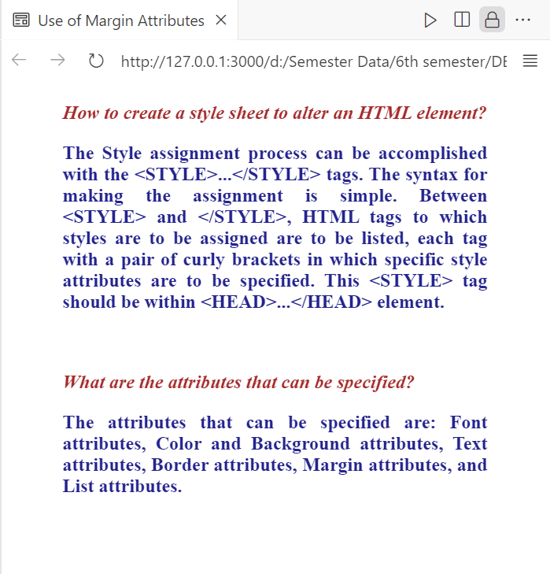

**Description:**

This HTML page demonstrates the use of CSS to style text elements. It applies **margins**, **font styles**, and **colors** to <p> elements using CSS inside the <style> tag. The **questions** are styled in **brown and italic**, while the **answers** are in **blue**. The text is justified with **10% left and right margins** for better readability.

**-------------------------Task 3.5--------------------------**

**Homework 4:** Bootstrap 5.2.3 Examples: Go through the following examples in bootstrap-5.2.3-examples.zip: **sign-in, cover, checkout, and blog.** Modify these examples for a real-world application. Submit the modified web pages and respective HTML and CSS files with description.

**UrbanGardenHaven:**

**Cover Page Code:**

<!doctype html>

<html lang="en" data-bs-theme="auto">

<head>

  <meta charset="utf-8">

  <meta name="viewport" content="width=device-width, initial-scale=1">

  <title>Urban Garden Haven · Home</title>

  <!-- Bootstrap CSS (CDN) -->

  <link

    href="https://cdn.jsdelivr.net/npm/bootstrap@5.3.0/dist/css/bootstrap.min.css"

    rel="stylesheet"

  >

  <style>

    /* Basic page styling */

    body {

      margin: 0;

      padding: 0;

      background-color: #f8f9fa;

      color: #212529;

      font-weight: 400;

    }

    .cover-header {

      margin-top: 5rem; /* Space for fixed navbar */

    }

    .hero {

      background: url('https://source.unsplash.com/1600x900/?garden,plants') center/cover no-repeat;

      min-height: 80vh;

      display: flex;

      justify-content: center;

      align-items: center;

    }

    .hero-content {

      background-color: rgba(255, 255, 255, 0.8);

      padding: 2rem;

      border-radius: 0.5rem;

      max-width: 700px;

      margin: 0 auto;

      text-align: center;

    }

    .cover-title {

      font-size: 2rem;

      font-weight: 600;

    }

  </style>

</head>

<body>

  <!-- NAVBAR -->

  <nav class="navbar navbar-expand-lg navbar-dark bg-success fixed-top">

    <div class="container-fluid">

      <a class="navbar-brand fw-bold" href="cover.html">Urban Garden Haven</a>

      <button

        class="navbar-toggler"

        type="button"

        data-bs-toggle="collapse"

        data-bs-target="#navbarNav"

        aria-controls="navbarNav"

        aria-expanded="false"

        aria-label="Toggle navigation"

      >

        <span class="navbar-toggler-icon"></span>

      </button>

      <div class="collapse navbar-collapse" id="navbarNav">

        <ul class="navbar-nav ms-auto">

          <li class="nav-item">

            <a class="nav-link active" aria-current="page" href="cover.html">Home</a>

          </li>

          <li class="nav-item">

            <a class="nav-link" href="blog.html">Blog</a>

          </li>

          <li class="nav-item">

            <a class="nav-link" href="checkout.html">Checkout</a>

          </li>

          <li class="nav-item">

            <a class="nav-link" href="sign-in.html">Sign In</a>

          </li>

        </ul>

      </div>

    </div>

  </nav>

  <!-- HERO / COVER SECTION -->

  <div class="cover-header hero">

    <div class="hero-content">

      <h2 class="cover-title">Urban Garden Haven</h2>

      <p class="lead mb-4">

        Bring nature to your doorstep with our eco-friendly gardening products,

        tips, and community blog. Whether you’re a beginner or a seasoned pro,

        we’ve got everything you need to nurture your green thumb.

      </p>

      <a href="blog.html" class="btn btn-success">Explore Our Blog</a>

    </div>

  </div>

  <!-- IMAGE GALLERY SECTION -->

  <div class="container my-5">

    <h3 class="mb-4 text-center">Our Garden Gallery</h3>

    <div class="row row-cols-1 row-cols-md-3 g-3">

      <!-- Image 1 -->

      <div class="col">

        <a href="#" data-bs-toggle="modal" data-bs-target="#modal1">

          <img src="images/1.jpg" alt="Tulip" class="img-fluid rounded shadow">

        </a>

        <p class="text-center fw-semibold mt-2 mb-0">Tulip - $5</p>

      </div>

      <!-- Image 2 -->

      <div class="col">

        <a href="#" data-bs-toggle="modal" data-bs-target="#modal2">

          <img src="images/2.jpg" alt="Rose" class="img-fluid rounded shadow">

        </a>

        <p class="text-center fw-semibold mt-2 mb-0">Rose - $7</p>

      </div>

      <!-- Image 3 -->

      <div class="col">

        <a href="#" data-bs-toggle="modal" data-bs-target="#modal3">

          <img src="images/3.jpg" alt="Sunflower" class="img-fluid rounded shadow">

        </a>

        <p class="text-center fw-semibold mt-2 mb-0">Sunflower - $6</p>

      </div>

      <!-- Image 4 -->

      <div class="col">

        <a href="#" data-bs-toggle="modal" data-bs-target="#modal4">

          <img src="images/4.jpg" alt="Lily" class="img-fluid rounded shadow">

        </a>

        <p class="text-center fw-semibold mt-2 mb-0">Lily - $8</p>

      </div>

      <!-- Image 5 -->

      <div class="col">

        <a href="#" data-bs-toggle="modal" data-bs-target="#modal5">

          <img src="images/5.jpg" alt="Daisy" class="img-fluid rounded shadow">

        </a>

        <p class="text-center fw-semibold mt-2 mb-0">Daisy - $4</p>

      </div>

      <!-- Image 6 -->

      <div class="col">

        <a href="#" data-bs-toggle="modal" data-bs-target="#modal6">

          <img src="images/6.jpg" alt="Orchid" class="img-fluid rounded shadow">

        </a>

        <p class="text-center fw-semibold mt-2 mb-0">Orchid - $12</p>

      </div>

      <!-- Image 7 -->

      <div class="col">

        <a href="#" data-bs-toggle="modal" data-bs-target="#modal7">

          <img src="images/7.jpg" alt="Jasmine" class="img-fluid rounded shadow">

        </a>

        <p class="text-center fw-semibold mt-2 mb-0">Jasmine - $9</p>

      </div>

      <!-- Image 8 -->

      <div class="col">

        <a href="#" data-bs-toggle="modal" data-bs-target="#modal8">

          <img src="images/8.jpg" alt="Marigold" class="img-fluid rounded shadow">

        </a>

        <p class="text-center fw-semibold mt-2 mb-0">Marigold - $3</p>

      </div>

      <!-- Image 9 -->

      <div class="col">

        <a href="#" data-bs-toggle="modal" data-bs-target="#modal9">

          <img src="images/9.jpg" alt="Daffodil" class="img-fluid rounded shadow">

        </a>

        <p class="text-center fw-semibold mt-2 mb-0">Daffodil - $5</p>

      </div>

      <!-- Image 10 -->

      <div class="col">

        <a href="#" data-bs-toggle="modal" data-bs-target="#modal10">

          <img src="images/10.jpg" alt="Carnation" class="img-fluid rounded shadow">

        </a>

        <p class="text-center fw-semibold mt-2 mb-0">Carnation - $6</p>

      </div>

      <!-- Image 11 -->

      <div class="col">

        <a href="#" data-bs-toggle="modal" data-bs-target="#modal11">

          <img src="images/11.jpg" alt="Hibiscus" class="img-fluid rounded shadow">

        </a>

        <p class="text-center fw-semibold mt-2 mb-0">Hibiscus - $10</p>

      </div>

      <!-- Image 12 -->

      <div class="col">

        <a href="#" data-bs-toggle="modal" data-bs-target="#modal12">

          <img src="images/12.jpg" alt="Chrysanthemum" class="img-fluid rounded shadow">

        </a>

        <p class="text-center fw-semibold mt-2 mb-0">Chrysanthemum - $11</p>

      </div>

    </div>

  </div>

  <!-- MODALS -->

  <!-- Modal 1 (Tulip) -->

  <div class="modal fade" id="modal1" tabindex="-1" aria-hidden="true">

    <div class="modal-dialog modal-dialog-centered">

      <div class="modal-content">

        <div class="modal-header">

          <h5 class="modal-title">Tulip - $5</h5>

          <button type="button" class="btn-close" data-bs-dismiss="modal" aria-label="Close"></button>

        </div>

        <div class="modal-body">

          <img src="images/1.jpg" alt="Tulip" class="img-fluid rounded mb-3">

          <p>

            Tulips are classic spring bulbs, known for their bright, cup-shaped blooms.

            They thrive in well-drained soil with plenty of sunlight. Plant them in the fall

            for a cheerful display when spring arrives!

          </p>

        </div>

      </div>

    </div>

  </div>

  <!-- Modal 2 (Rose) -->

  <div class="modal fade" id="modal2" tabindex="-1" aria-hidden="true">

    <div class="modal-dialog modal-dialog-centered">

      <div class="modal-content">

        <div class="modal-header">

          <h5 class="modal-title">Rose - $7</h5>

          <button type="button" class="btn-close" data-bs-dismiss="modal" aria-label="Close"></button>

        </div>

        <div class="modal-body">

          <img src="images/2.jpg" alt="Rose" class="img-fluid rounded mb-3">

          <p>

            Roses symbolize love and beauty. Modern rose varieties are surprisingly hardy,

            and with proper pruning, feeding, and sunlight, they can bloom throughout the season.

          </p>

        </div>

      </div>

    </div>

  </div>

  <!-- Modal 3 (Sunflower) -->

  <div class="modal fade" id="modal3" tabindex="-1" aria-hidden="true">

    <div class="modal-dialog modal-dialog-centered">

      <div class="modal-content">

        <div class="modal-header">

          <h5 class="modal-title">Sunflower - $6</h5>

          <button type="button" class="btn-close" data-bs-dismiss="modal" aria-label="Close"></button>

        </div>

        <div class="modal-body">

          <img src="images/3.jpg" alt="Sunflower" class="img-fluid rounded mb-3">

          <p>

            Sunflowers bring bright, cheerful energy to any garden.

            They love full sun and can grow quite tall, making them a striking addition to flower beds.

          </p>

        </div>

      </div>

    </div>

  </div>

  <!-- Modal 4 (Lily) -->

  <div class="modal fade" id="modal4" tabindex="-1" aria-hidden="true">

    <div class="modal-dialog modal-dialog-centered">

      <div class="modal-content">

        <div class="modal-header">

          <h5 class="modal-title">Lily - $8</h5>

          <button type="button" class="btn-close" data-bs-dismiss="modal" aria-label="Close"></button>

        </div>

        <div class="modal-body">

          <img src="images/4.jpg" alt="Lily" class="img-fluid rounded mb-3">

          <p>

            Lilies are prized for their elegant blooms and sweet fragrance.

            They come in many varieties, each adding a touch of sophistication to any garden or bouquet.

          </p>

        </div>

      </div>

    </div>

  </div>

  <!-- Modal 5 (Daisy) -->

  <div class="modal fade" id="modal5" tabindex="-1" aria-hidden="true">

    <div class="modal-dialog modal-dialog-centered">

      <div class="modal-content">

        <div class="modal-header">

          <h5 class="modal-title">Daisy - $4</h5>

          <button type="button" class="btn-close" data-bs-dismiss="modal" aria-label="Close"></button>

        </div>

        <div class="modal-body">

          <img src="images/5.jpg" alt="Daisy" class="img-fluid rounded mb-3">

          <p>

            Daisies are simple, charming flowers that brighten any space.

            They’re easy to grow and prefer sunny spots with well-draining soil.

          </p>

        </div>

      </div>

    </div>

  </div>

  <!-- Modal 6 (Orchid) -->

  <div class="modal fade" id="modal6" tabindex="-1" aria-hidden="true">

    <div class="modal-dialog modal-dialog-centered">

      <div class="modal-content">

        <div class="modal-header">

          <h5 class="modal-title">Orchid - $12</h5>

          <button type="button" class="btn-close" data-bs-dismiss="modal" aria-label="Close"></button>

        </div>

        <div class="modal-body">

          <img src="images/6.jpg" alt="Orchid" class="img-fluid rounded mb-3">

          <p>

            Orchids add an exotic touch to indoor gardens. They thrive in warm, humid conditions

            with indirect light, rewarding you with long-lasting, stunning blooms.

          </p>

        </div>

      </div>

    </div>

  </div>

  <!-- Modal 7 (Jasmine) -->

  <div class="modal fade" id="modal7" tabindex="-1" aria-hidden="true">

    <div class="modal-dialog modal-dialog-centered">

      <div class="modal-content">

        <div class="modal-header">

          <h5 class="modal-title">Jasmine - $9</h5>

          <button type="button" class="btn-close" data-bs-dismiss="modal" aria-label="Close"></button>

        </div>

        <div class="modal-body">

          <img src="images/7.jpg" alt="Jasmine" class="img-fluid rounded mb-3">

          <p>

            Jasmine is cherished for its sweet fragrance. This climbing plant

            can be grown in pots or outdoors, filling the air with a delightful scent.

          </p>

        </div>

      </div>

    </div>

  </div>

  <!-- Modal 8 (Marigold) -->

  <div class="modal fade" id="modal8" tabindex="-1" aria-hidden="true">

    <div class="modal-dialog modal-dialog-centered">

      <div class="modal-content">

        <div class="modal-header">

          <h5 class="modal-title">Marigold - $3</h5>

          <button type="button" class="btn-close" data-bs-dismiss="modal" aria-label="Close"></button>

        </div>

        <div class="modal-body">

          <img src="images/8.jpg" alt="Marigold" class="img-fluid rounded mb-3">

          <p>

            Marigolds are bright, hardy annuals that help repel garden pests.

            Their warm orange and yellow hues make them a favorite for edging flower beds.

          </p>

        </div>

      </div>

    </div>

  </div>

  <!-- Modal 9 (Daffodil) -->

  <div class="modal fade" id="modal9" tabindex="-1" aria-hidden="true">

    <div class="modal-dialog modal-dialog-centered">

      <div class="modal-content">

        <div class="modal-header">

          <h5 class="modal-title">Daffodil - $5</h5>

          <button type="button" class="btn-close" data-bs-dismiss="modal" aria-label="Close"></button>

        </div>

        <div class="modal-body">

          <img src="images/9.jpg" alt="Daffodil" class="img-fluid rounded mb-3">

          <p>

            Daffodils are a sure sign of spring. These bulbs produce trumpet-like flowers

            that come back year after year with minimal care.

          </p>

        </div>

      </div>

    </div>

  </div>

  <!-- Modal 10 (Carnation) -->

  <div class="modal fade" id="modal10" tabindex="-1" aria-hidden="true">

    <div class="modal-dialog modal-dialog-centered">

      <div class="modal-content">

        <div class="modal-header">

          <h5 class="modal-title">Carnation - $6</h5>

          <button type="button" class="btn-close" data-bs-dismiss="modal" aria-label="Close"></button>

        </div>

        <div class="modal-body">

          <img src="images/10.jpg" alt="Carnation" class="img-fluid rounded mb-3">

          <p>

            Carnations are known for their ruffled petals and subtle clove-like scent.

            They’re popular in bouquets and come in a wide range of colors.

          </p>

        </div>

      </div>

    </div>

  </div>

  <!-- Modal 11 (Hibiscus) -->

  <div class="modal fade" id="modal11" tabindex="-1" aria-hidden="true">

    <div class="modal-dialog modal-dialog-centered">

      <div class="modal-content">

        <div class="modal-header">

          <h5 class="modal-title">Hibiscus - $10</h5>

          <button type="button" class="btn-close" data-bs-dismiss="modal" aria-label="Close"></button>

        </div>

        <div class="modal-body">

          <img src="images/11.jpg" alt="Hibiscus" class="img-fluid rounded mb-3">

          <p>

            Hibiscus plants produce large, tropical-looking blooms. They prefer

            warm temperatures and plenty of sunlight, rewarding you with spectacular flowers.

          </p>

        </div>

      </div>

    </div>

  </div>

  <!-- Modal 12 (Chrysanthemum) -->

  <div class="modal fade" id="modal12" tabindex="-1" aria-hidden="true">

    <div class="modal-dialog modal-dialog-centered">

      <div class="modal-content">

        <div class="modal-header">

          <h5 class="modal-title">Chrysanthemum - $11</h5>

          <button type="button" class="btn-close" data-bs-dismiss="modal" aria-label="Close"></button>

        </div>

        <div class="modal-body">

          <img src="images/12.jpg" alt="Chrysanthemum" class="img-fluid rounded mb-3">

          <p>

            Chrysanthemums (or “mums”) bloom in vibrant shades of red, orange, yellow, and more.

            They’re a staple of autumn gardens, bringing color late into the season.

          </p>

        </div>

      </div>

    </div>

  </div>

  <footer class="my-5 pt-5 text-center text-muted">

    <p>&copy; 2025 Urban Garden Haven</p>

  </footer>

  <!-- Bootstrap JS (CDN) -->

  <script

    src="https://cdn.jsdelivr.net/npm/bootstrap@5.3.0/dist/js/bootstrap.bundle.min.js"

  ></script>

</body>

</html>

**Blog code:**

<!doctype html>

<html lang="en" data-bs-theme="auto">

<head>

  <meta charset="utf-8">

  <meta name="viewport" content="width=device-width, initial-scale=1">

  <title>Urban Garden Haven · Blog</title>

  <!-- Bootstrap CSS -->

  <link href="https://cdn.jsdelivr.net/npm/bootstrap@5.3.0/dist/css/bootstrap.min.css" rel="stylesheet">

  <style>

    body {

      background: url("images/background.jpg") center/cover no-repeat;

      background-attachment: fixed;

    }

    .blog-header {

      margin-top: 6rem;

      text-align: center;

    }

    .blog-title {

      font-weight: 700;

      color: #155724;

      font-size: 2.5rem;

    }

    .lead {

      color: #4a4a4a;

    }

    .blog-container {

      max-width: 800px;

      margin: auto;

    }

    .blog-post {

      background: white;

      padding: 20px;

      border-radius: 10px;

      box-shadow: 0 4px 8px rgba(0, 0, 0, 0.1);

      margin-bottom: 2rem;

      border-left: 6px solid;

    }

    /* Unique colors for each post */

    .post-1 { border-color: #ff6b6b; }

    .post-2 { border-color: #1e88e5; }

    .post-3 { border-color: #ff9800; }

    .post-4 { border-color: #9c27b0; }

    .post-5 { border-color: #4caf50; }

    .blog-post-title {

      margin-bottom: 0.5rem;

      font-weight: bold;

    }

    /* Heading colors */

    .post-1 h3 { color: #ff6b6b; }

    .post-2 h3 { color: #1e88e5; }

    .post-3 h3 { color: #ff9800; }

    .post-4 h3 { color: #9c27b0; }

    .post-5 h3 { color: #4caf50; }

    .blog-post-meta {

      color: #6c757d;

      font-style: italic;

    }

    footer {

      text-align: center;

      color: white;

      margin-top: 2rem;

      padding: 1rem;

      background: rgba(0, 0, 0, 0.6);

    }

  </style>

</head>

<body>

  <!-- ======= NAVBAR ======= -->

  <nav class="navbar navbar-expand-lg navbar-dark bg-success fixed-top">

    <div class="container-fluid">

      <a class="navbar-brand fw-bold" href="blog.html">Urban Garden Haven</a>

      <button class="navbar-toggler" type="button" data-bs-toggle="collapse" data-bs-target="#navbarNav">

        <span class="navbar-toggler-icon"></span>

      </button>

      <div class="collapse navbar-collapse" id="navbarNav">

        <ul class="navbar-nav ms-auto">

          <li class="nav-item"><a class="nav-link" href="cover.html">Home</a></li>

          <li class="nav-item"><a class="nav-link active" href="blog.html">Blog</a></li>

          <li class="nav-item"><a class="nav-link" href="checkout.html">Checkout</a></li>

          <li class="nav-item"><a class="nav-link" href="sign-in.html">Sign In</a></li>

        </ul>

      </div>

    </div>

  </nav>

  <!-- ======= END NAVBAR ======= -->

  <div class="container blog-header">

    <h2 class="blog-title">Urban Garden Haven Blog</h2>

    <p class="lead">Tips, guides, and inspiration for your home garden.</p>

  </div>

  <div class="blog-container">

    <!-- Post 1 -->

    <div class="blog-post post-1">

      <h3 class="blog-post-title">The Beauty of Tulips: A Springtime Favorite</h3>

      <p class="blog-post-meta">March 12, 2025 by <a href="#">Admin</a></p>

      <p>Tulips are known for their vibrant colors and variety of shapes, making them a popular choice for spring gardens...</p>

    </div>

    <!-- Post 2 -->

    <div class="blog-post post-2">

      <h3 class="blog-post-title">Growing Roses: A Timeless Classic</h3>

      <p class="blog-post-meta">March 10, 2025 by <a href="#">Admin</a></p>

      <p>Roses are a symbol of love and beauty worldwide. While they have a reputation for being finicky, modern varieties...</p>

    </div>

    <!-- Post 3 -->

    <div class="blog-post post-3">

      <h3 class="blog-post-title">Sunflowers: Bringing Brightness and Joy</h3>

      <p class="blog-post-meta">March 5, 2025 by <a href="#">Admin</a></p>

      <p>Sunflowers are beloved for their large, cheerful blooms that follow the sun throughout the day...</p>

    </div>

    <!-- Post 4 -->

    <div class="blog-post post-4">

      <h3 class="blog-post-title">Lily Care: Elegance in Your Garden</h3>

      <p class="blog-post-meta">February 28, 2025 by <a href="#">Admin</a></p>

      <p>Lilies are prized for their exquisite blooms and sweet fragrance. They come in a variety of types...</p>

    </div>

    <!-- Post 5 -->

    <div class="blog-post post-5">

      <h3 class="blog-post-title">Orchids: Exotic Blooms at Home</h3>

      <p class="blog-post-meta">February 20, 2025 by <a href="#">Admin</a></p>

      <p>Orchids are famous for their exotic shapes and long-lasting blooms, often associated with tropical climates...</p>

    </div>

  </div>

  <footer>

    <p>&copy; 2025 Urban Garden Haven</p>

  </footer>

  <!-- Bootstrap JS -->

  <script src="https://cdn.jsdelivr.net/npm/bootstrap@5.3.0/dist/js/bootstrap.bundle.min.js"></script>

</body>

</html>

**check out:**

<!doctype html>

<html lang="en" data-bs-theme="auto">

  <head>

    <meta charset="utf-8">

    <meta name="viewport" content="width=device-width, initial-scale=1">

    <title>Urban Garden Haven · Checkout</title>

    <!-- Bootstrap CSS -->

    <link href="https://cdn.jsdelivr.net/npm/bootstrap@5.3.0/dist/css/bootstrap.min.css" rel="stylesheet">

    <!-- Custom CSS -->

    <link href="checkout.css" rel="stylesheet">

  </head>

  <body class="bg-light">

    <!-- ======= NAVBAR ======= -->

    <nav class="navbar navbar-expand-lg navbar-dark bg-success fixed-top">

      <div class="container-fluid">

        <a class="navbar-brand fw-bold" href="blog.html">Urban Garden Haven</a>

        <button class="navbar-toggler" type="button" data-bs-toggle="collapse" data-bs-target="#navbarNav"

          aria-controls="navbarNav" aria-expanded="false" aria-label="Toggle navigation">

          <span class="navbar-toggler-icon"></span>

        </button>

        <div class="collapse navbar-collapse" id="navbarNav">

          <ul class="navbar-nav ms-auto">

            <li class="nav-item">

              <a class="nav-link" href="cover.html">Home</a>

            </li>

            <li class="nav-item">

              <a class="nav-link" href="blog.html">Blog</a>

            </li>

            <li class="nav-item">

              <a class="nav-link active" aria-current="page" href="checkout.html">Checkout</a>

            </li>

            <li class="nav-item">

              <a class="nav-link" href="sign-in.html">Sign In</a>

            </li>

          </ul>

        </div>

      </div>

    </nav>

    <!-- ======= END NAVBAR ======= -->

    <div class="container" style="margin-top: 5rem;">

      <main>

        <div class="py-5 text-center">

          <h2>Urban Garden Haven Checkout</h2>

          <p class="lead">

            Complete your purchase of seeds, plants, and gardening accessories.

            Fill in the form below to place your order.

          </p>

        </div>

        <div class="row g-5">

          <!-- Cart summary -->

          <div class="col-md-5 col-lg-4 order-md-last">

            <h4 class="d-flex justify-content-between align-items-center mb-3">

              <span class="text-primary">Your cart</span>

              <span class="badge bg-primary rounded-pill">3</span>

            </h4>

            <ul class="list-group mb-3">

              <li class="list-group-item d-flex justify-content-between lh-sm">

                <div>

                  <h6 class="my-0">Organic Basil Seeds</h6>

                  <small class="text-body-secondary">Heirloom variety</small>

                </div>

                <span class="text-body-secondary">$5</span>

              </li>

              <li class="list-group-item d-flex justify-content-between lh-sm">

                <div>

                  <h6 class="my-0">Terracotta Pot</h6>

                  <small class="text-body-secondary">Medium size</small>

                </div>

                <span class="text-body-secondary">$10</span>

              </li>

              <li class="list-group-item d-flex justify-content-between lh-sm">

                <div>

                  <h6 class="my-0">Garden Gloves</h6>

                  <small class="text-body-secondary">One pair</small>

                </div>

                <span class="text-body-secondary">$8</span>

              </li>

              <li class="list-group-item d-flex justify-content-between bg-body-tertiary">

                <div class="text-success">

                  <h6 class="my-0">Promo code</h6>

                  <small>GARDEN10</small>

                </div>

                <span class="text-success">−$3</span>

              </li>

              <li class="list-group-item d-flex justify-content-between">

                <span>Total (USD)</span>

                <strong>$20</strong>

              </li>

            </ul>

            <form class="card p-2">

              <div class="input-group">

                <input type="text" class="form-control" placeholder="Promo code">

                <button type="submit" class="btn btn-secondary">Redeem</button>

              </div>

            </form>

          </div>

          <!-- Billing & Shipping Form -->

          <div class="col-md-7 col-lg-8">

            <h4 class="mb-3">Billing address</h4>

            <form class="needs-validation" novalidate>

              <div class="row g-3">

                <div class="col-sm-6">

                  <label for="firstName" class="form-label">First name</label>

                  <input type="text" class="form-control" id="firstName" placeholder="" required>

                  <div class="invalid-feedback">

                    Valid first name is required.

                  </div>

                </div>

                <div class="col-sm-6">

                  <label for="lastName" class="form-label">Last name</label>

                  <input type="text" class="form-control" id="lastName" placeholder="" required>

                  <div class="invalid-feedback">

                    Valid last name is required.

                  </div>

                </div>

                <div class="col-12">

                  <label for="username" class="form-label">Username</label>

                  <div class="input-group has-validation">

                    <span class="input-group-text">@</span>

                    <input type="text" class="form-control" id="username" placeholder="Username" required>

                    <div class="invalid-feedback">

                      Your username is required.

                    </div>

                  </div>

                </div>

                <div class="col-12">

                  <label for="email" class="form-label">Email <span class="text-body-secondary">(Optional)</span></label>

                  <input type="email" class="form-control" id="email" placeholder="you@example.com">

                  <div class="invalid-feedback">

                    Please enter a valid email address for shipping updates.

                  </div>

                </div>

                <div class="col-12">

                  <label for="address" class="form-label">Address</label>

                  <input type="text" class="form-control" id="address" placeholder="1234 Main St" required>

                  <div class="invalid-feedback">

                    Please enter your shipping address.

                  </div>

                </div>

                <div class="col-12">

                  <label for="address2" class="form-label">Address 2 <span class="text-body-secondary">(Optional)</span></label>

                  <input type="text" class="form-control" id="address2" placeholder="Apartment or suite">

                </div>

                <div class="col-md-5">

                  <label for="country" class="form-label">Country</label>

                  <select class="form-select" id="country" required>

                    <option value="">Choose...</option>

                    <option>United States</option>

                    <option>Pakistan</option>

                    <option>Canada</option>

                  </select>

                  <div class="invalid-feedback">

                    Please select a valid country.

                  </div>

                </div>

                <div class="col-md-4">

                  <label for="state" class="form-label">State</label>

                  <select class="form-select" id="state" required>

                    <option value="">Choose...</option>

                    <option>California</option>

                    <option>Alberta</option>

                    <option>Khyber Pakhtunkhwa</option>

                  </select>

                  <div class="invalid-feedback">

                    Please provide a valid state.

                  </div>

                </div>

                <div class="col-md-3">

                  <label for="zip" class="form-label">Zip</label>

                  <input type="text" class="form-control" id="zip" placeholder="" required>

                  <div class="invalid-feedback">

                    Zip code required.

                  </div>

                </div>

              </div>

              <hr class="my-4">

              <div class="form-check">

                <input type="checkbox" class="form-check-input" id="same-address">

                <label class="form-check-label" for="same-address">Shipping address is the same as my billing address</label>

              </div>

              <div class="form-check">

                <input type="checkbox" class="form-check-input" id="save-info">

                <label class="form-check-label" for="save-info">Save this information for next time</label>

              </div>

              <hr class="my-4">

              <h4 class="mb-3">Payment</h4>

              <div class="my-3">

                <div class="form-check">

                  <input id="credit" name="paymentMethod" type="radio" class="form-check-input" checked required>

                  <label class="form-check-label" for="credit">Credit card</label>

                </div>

                <div class="form-check">

                  <input id="debit" name="paymentMethod" type="radio" class="form-check-input" required>

                  <label class="form-check-label" for="debit">Debit card</label>

                </div>

                <div class="form-check">

                  <input id="paypal" name="paymentMethod" type="radio" class="form-check-input" required>

                  <label class="form-check-label" for="paypal">PayPal</label>

                </div>

              </div>

              <div class="row gy-3">

                <div class="col-md-6">

                  <label for="cc-name" class="form-label">Name on card</label>

                  <input type="text" class="form-control" id="cc-name" placeholder="" required>

                  <small class="text-body-secondary">Full name as displayed on card</small>

                  <div class="invalid-feedback">

                    Name on card is required

                  </div>

                </div>

                <div class="col-md-6">

                  <label for="cc-number" class="form-label">Credit card number</label>

                  <input type="text" class="form-control" id="cc-number" placeholder="" required>

                  <div class="invalid-feedback">

                    Credit card number is required

                  </div>

                </div>

                <div class="col-md-3">

                  <label for="cc-expiration" class="form-label">Expiration</label>

                  <input type="text" class="form-control" id="cc-expiration" placeholder="" required>

                  <div class="invalid-feedback">

                    Expiration date required

                  </div>

                </div>

                <div class="col-md-3">

                  <label for="cc-cvv" class="form-label">CVV</label>

                  <input type="text" class="form-control" id="cc-cvv" placeholder="" required>

                  <div class="invalid-feedback">

                    Security code required

                  </div>

                </div>

              </div>

              <hr class="my-4">

              <button class="w-100 btn btn-success btn-lg" type="submit">Complete Purchase</button>

            </form>

          </div>

        </div>

      </main>

      <footer class="my-5 pt-5 text-center text-muted">

        <p class="mb-1">&copy; 2025 Urban Garden Haven</p>

      </footer>

    </div>

    <!-- Bootstrap Bundle JS -->

    <script src="https://cdn.jsdelivr.net/npm/bootstrap@5.3.0/dist/js/bootstrap.bundle.min.js"></script>

    <!-- Custom JS -->

    <script src="checkout.js"></script>

  </body>

</html>

**Sign-in**<!doctype html>

<html lang="en" data-bs-theme="auto">

  <head>

    <!-- Required meta tags -->

    <meta charset="utf-8">

    <meta name="viewport" content="width=device-width, initial-scale=1">

    <title>Urban Garden Haven · Sign In</title>

    <!-- Bootstrap CSS -->

    <link href="https://cdn.jsdelivr.net/npm/bootstrap@5.3.0/dist/css/bootstrap.min.css" rel="stylesheet">

    <!-- Custom CSS -->

    <link href="sign-in.css" rel="stylesheet">

  </head>

  <body class="d-flex align-items-center py-4 bg-light">

    <!-- ======= NAVBAR ======= -->

    <nav class="navbar navbar-expand-lg navbar-dark bg-success fixed-top">

      <div class="container-fluid">

        <a class="navbar-brand fw-bold" href="blog.html">Urban Garden Haven</a>

        <button class="navbar-toggler" type="button" data-bs-toggle="collapse" data-bs-target="#navbarNav"

          aria-controls="navbarNav" aria-expanded="false" aria-label="Toggle navigation">

          <span class="navbar-toggler-icon"></span>

        </button>

        <div class="collapse navbar-collapse" id="navbarNav">

          <ul class="navbar-nav ms-auto">

            <li class="nav-item">

              <a class="nav-link" href="cover.html">Home</a>

            </li>

            <li class="nav-item">

              <a class="nav-link" href="blog.html">Blog</a>

            </li>

            <li class="nav-item">

              <a class="nav-link" href="checkout.html">Checkout</a>

            </li>

            <li class="nav-item">

              <a class="nav-link active" aria-current="page" href="sign-in.html">Sign In</a>

            </li>

          </ul>

        </div>

      </div>

    </nav>

    <!-- ======= END NAVBAR ======= -->

    <main class="form-signin w-100 m-auto" style="margin-top: 5rem !important;">

      <form>

        <h1 class="h3 mb-3 fw-normal text-center">Welcome Back</h1>

        <div class="form-floating mb-2">

          <input type="email" class="form-control" id="floatingInput" placeholder="name@example.com">

          <label for="floatingInput">Email address</label>

        </div>

        <div class="form-floating mb-3">

          <input type="password" class="form-control" id="floatingPassword" placeholder="Password">

          <label for="floatingPassword">Password</label>

        </div>

        <div class="form-check text-start my-3">

          <input class="form-check-input" type="checkbox" value="remember-me" id="flexCheckDefault">

          <label class="form-check-label" for="flexCheckDefault">

            Remember me

          </label>

        </div>

        <button class="btn btn-success w-100 py-2" type="submit">Sign in</button>

        <p class="mt-4 text-center text-muted">&copy; 2025 Urban Garden Haven</p>

      </form>

    </main>

    <!-- Bootstrap Bundle with Popper -->

    <script src="https://cdn.jsdelivr.net/npm/bootstrap@5.3.0/dist/js/bootstrap.bundle.min.js"></script>

  </body>

</html>

**Cover CSS code:**

/*

 * Custom Cover Page Styles

 * Based on Bootstrap’s Cover example

 */

/* Set background color similar to Sign-In, Blog, and Checkout pages */

body {

    background-color: #f8f9fa; /* Light Gray (Bootstrap Default) */

    color: black; /* Dark Text */

  }

  /* Override Bootstrap dark theme */

  .text-bg-dark {

    background-color: #f8f9fa !important;

    color: #212529 !important;

  }

.a{

    color:black;

}

/* Center container constraints */

.cover-container {

  max-width: 42em;

}

/* Navbar links */

.nav-masthead .nav-link {

  color: rgba(255, 255, 255, 0.5);

  border-bottom: 0.25rem solid transparent;

  margin-left: 1rem;

  flex: 1;

}

.nav-masthead .nav-link:hover,

.nav-masthead .nav-link:focus {

  border-bottom-color: rgba(255, 255, 255, 0.25);

}

.nav-masthead .active {

  color: #fff;

  border-bottom-color: #fff;

}

/* Custom button styling */

.btn-light,

.btn-light:hover,

.btn-light:focus {

  color: #333;

  text-shadow: none; /* Prevent white text shadow on the button */

}

**Sign-in CSS:**

html,

body {

  height: 100%;

  margin: 0;

  padding: 0;

}

.form-signin {

  max-width: 400px;

  padding: 1rem;

}

.form-signin input[type="email"],

.form-signin input[type="password"] {

  border-radius: 0;

  margin-bottom: 0;

}

.form-signin .form-check {

  margin-top: 1rem;

}

**Check-out css:**

.container {

  max-width: 960px;

}

**OUTPUT:**

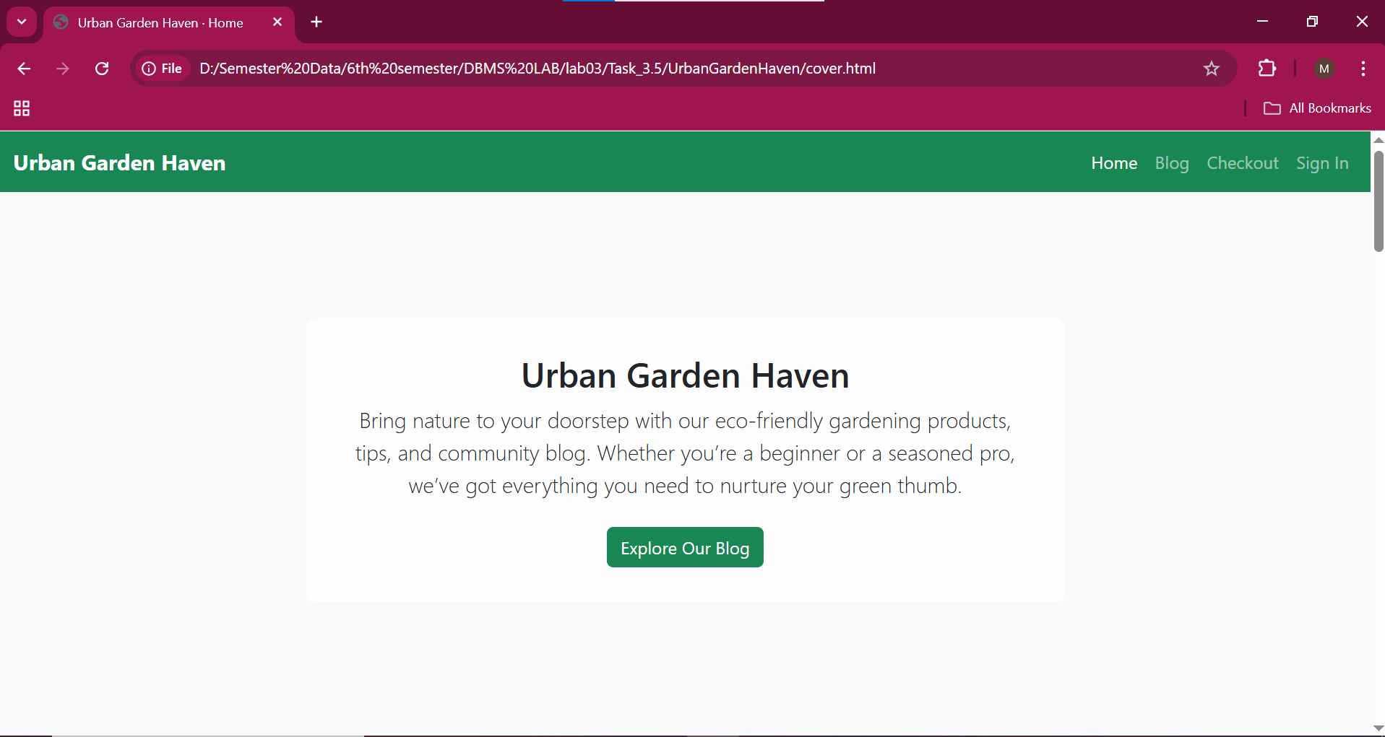

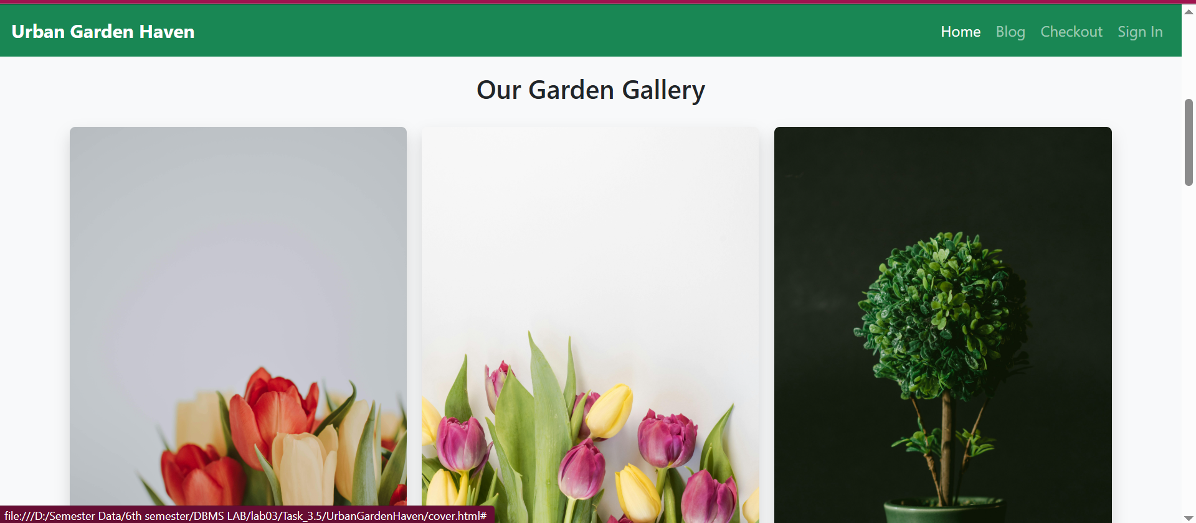

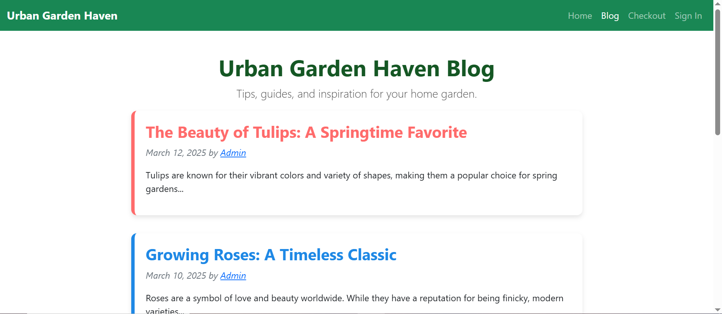

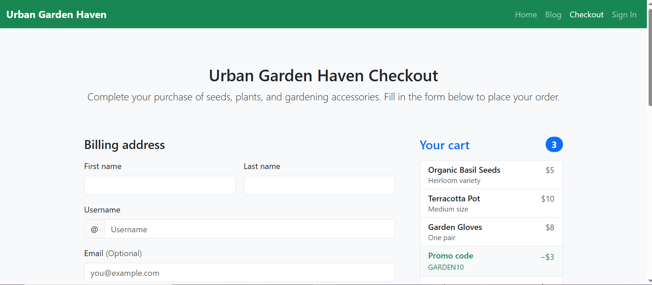

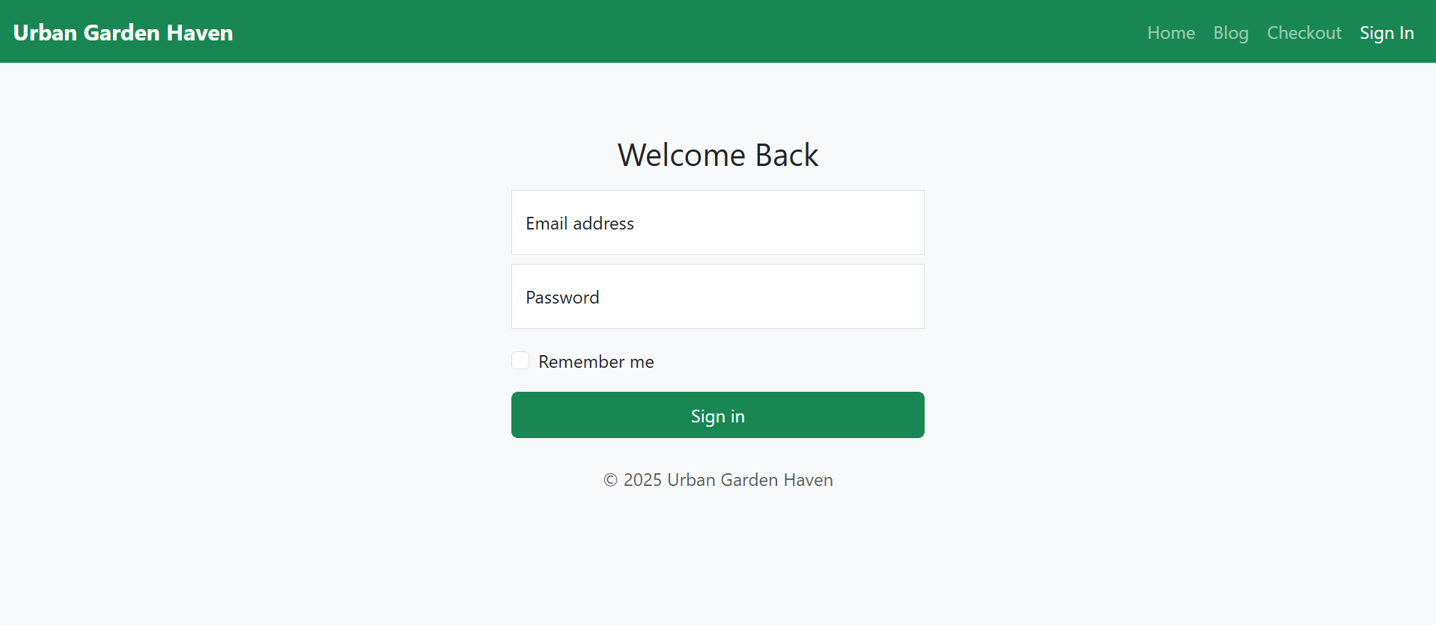

**Description:**

1. **Navbar**
2. Uses a **fixed-top** Bootstrap navbar (navbar-dark bg-success) with links to **Home**, **Blog**, **Checkout**, and **Sign In**.
3. **Hero / Cover Section**
4. A **full-width background image** (https://source.unsplash.com/1600x900/?garden,plants) and a **white overlay** (.hero-content) for readability.
5. Contains a **title**, a **short paragraph**, and a **call-to-action** button linking to the **blog**.
6. **Image Gallery**
7. A **Bootstrap grid** (row row-cols-1 row-cols-md-3 g-3) showing **12 images**.
8. Each image has a **price** caption below it and **opens a modal** on click.
9. **Modals**
10. **12 modals** correspond to each image, using **data-bs-toggle="modal"** and **data-bs-target="#modalX"**.
11. Each modal displays **an image** and a **short description** of the flower.
12. **Footer**
13. A simple footer with **copyright** text.
14. **Bootstrap Integration**
15. Uses **CDN** links for **Bootstrap CSS** and **Bootstrap JS** (with Popper).

**-------------------------TASK 3.6--------------------------**

**HOMEWORK 5:** MODIFY YOUR CV DESIGNED USING PLAIN HTML IN LAB 02 BY ADDING THE CSS AND BOOTSTRAP IN IT. UPLOAD BOTH ORIGINAL ONE AND MODIFIED ONE ON THE HOSTING SITE. PROVIDE THE LINK.

**Using Html:**

<https://bejewelled-cat-352cfd.netlify.app/>

**Using Html+CSS:**

**Html Code:**

<!DOCTYPE html>

<html lang="en">

<head>

    <meta charset="UTF-8">

    <meta name="viewport" content="width=device-width, initial-scale=1.0">

    <title>Mohsin Sajjad - CV</title>

    <link rel="stylesheet" href="styles.css">

</head>

<body>

    <div class="container">

        <div class="sidebar">

            <h2>Mohsin Sajjad</h2>

            <p class="title">Student</p>

            <h3>Contact</h3>

            <ul class="contact-list">

                <li>📞 +923125432079</li>

                <li>✉️ 22pwcse2149@uetpeshawar.edu.pk</li>

                <li>📍 Village Granthali, District Mansehra</li>

            </ul>

            <h3>About Me</h3>

            <p>Quick learner with strong programming, embedded systems, and networking skills. Passionate about problem-solving and continuous learning. Awarded a laptop under the PM Laptop Scheme for high GPA. Committed to innovation and efficiency.</p>

            <h3>Skills</h3>

            <ul class="skills-list">

                <li>Programming: C/C++, Python</li>

                <li>Networking: OSI, TCP/IP, Protocols</li>

                <li>Operating System: Linux</li>

                <li>Software Development: DSA</li>

                <li>Communication and Teamwork</li>

                <li>Problem Solving and Critical Thinking</li>

            </ul>

        </div>

        <div class="content">

            <h3>Education</h3>

            <ul class="education-list">

                <li><strong>BSc: Computer System Engineering</strong><br>University of Engineering And Technology Peshawar (2022 - 2026)</li>

                <li><strong>Intermediate: Pre-Engineering (CS)</strong><br>Borcelle University (2020 - 2022)</li>

                <li><strong>Matriculation: Science</strong><br>Govt. High School Dadar (2018 - 2020)</li>

            </ul>

            <h3>Work Experience</h3>

            <ul class="work-list">

                <li><strong>Clap Switch (Sensor-Based Circuit)</strong><br>Designed using a microphone sensor and amplifiers to control devices with a clap sound.</li>

                <li><strong>Racing Monkey (ESP32-Based Robotics Project)</strong><br>Remote-controlled racing robot using ESP32, motors, and sensors.</li>

                <li><strong>Job Scheduler (Shell-Based)</strong><br>Reads user commands and runs tasks sequentially.</li>

                <li><strong>Space Mission Control System Simulation</strong><br>C simulation enabling communication between mission control and Earth.</li>

                <li><strong>Brick Breaker Game</strong><br>Developed using C and a graphics library (SFML).</li>

            </ul>

            <h3>Certificates and Achievements</h3>

            <ul class="certificates-list">

                <li>Awarded a laptop for high GPA (PM Laptop Scheme)</li>

                <li>Get Started with Python – Coursera</li>

                <li>Technical Support Fundamentals – Coursera</li>

                <li>Bits and Bytes of Networking – Coursera</li>

                <li>Operating Systems – Coursera</li>

            </ul>

        </div>

    </div>

</body>

</html>

**CSS:**

/* General Styles */

body {

    font-family: Arial, sans-serif;

    margin: 0;

    padding: 0;

    background-color: #f4f4f4;

    color: #333;

}

/* Container */

.container {

    display: flex;

    max-width: 1000px;

    margin: 20px auto;

    background: white;

    box-shadow: 0px 4px 8px rgba(0, 0, 0, 0.2);

    border-radius: 10px;

    overflow: hidden;

}

/* Sidebar */

.sidebar {

    width: 35%;

    background: #23238e;

    color: white;

    padding: 20px;

}

.sidebar h2 {

    font-size: 24px;

    margin-bottom: 5px;

}

.sidebar .title {

    font-style: italic;

    font-size: 16px;

    margin-bottom: 15px;

}

.sidebar h3 {

    margin-top: 20px;

    font-size: 18px;

    border-bottom: 2px solid white;

    padding-bottom: 5px;

}

.sidebar ul {

    list-style-type: none;

    padding: 0;

}

.sidebar ul li {

    margin: 10px 0;

}

/* Main Content */

.content {

    width: 65%;

    padding: 20px;

}

.content h3 {

    font-size: 20px;

    border-bottom: 2px solid #23238e;

    padding-bottom: 5px;

    margin-bottom: 10px;

}

ul {

    list-style-type: square;

    padding-left: 20px;

}

ul li {

    margin: 10px 0;

}

/* List Styles */

.contact-list li::before {

    content: "✔ ";

    color: #ffd700;

}

.skills-list li::before {

    content: "🔹 ";

    color: #23238e;

}

.work-list li::before {

    content: "🚀 ";

    color: #ff4500;

}

.certificates-list li::before {

    content: "🏆 ";

    color: #008000;

}

**LINK:**

[**https://67d2fb868beff215d8cdeab4--delightful-yeot-2a7e4d.netlify.app/**](https://67d2fb868beff215d8cdeab4--delightful-yeot-2a7e4d.netlify.app/)

**Output:**

